**Problem Statement 5: Daily Scrums : Google Sheet**

The attendance in the office is pure physical presence based , so we want to make sure that whenever anyone says ,”Present ‘name’ ” The sheet should separate the name and makes a list out of it

**Solution →**

Step 1 : Understanding

Requirements:

IFTTT Account,

Google Assistant App and Account,

Google Sheets

Step 2 : Ideating

We need to Connect Google Assistant and Google Sheets through IFTTT Applet .

Step 3 : Implementing

Open IFTTT website Click on create.

And Follow steps as shown below.

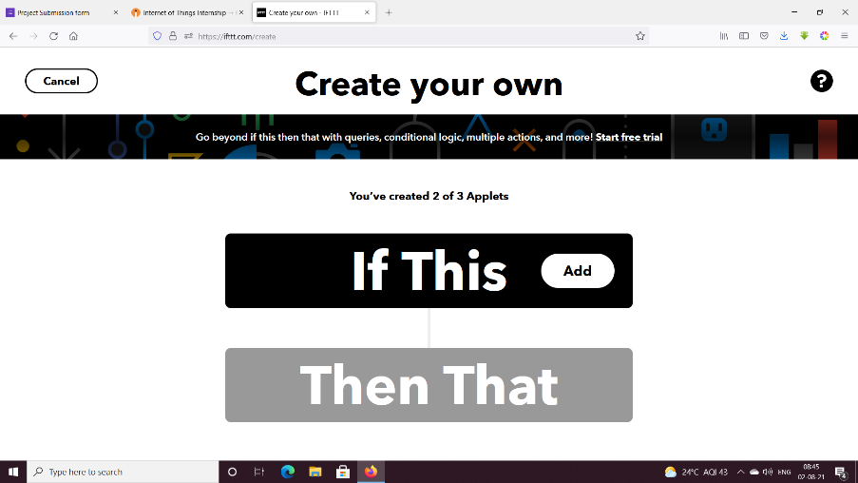

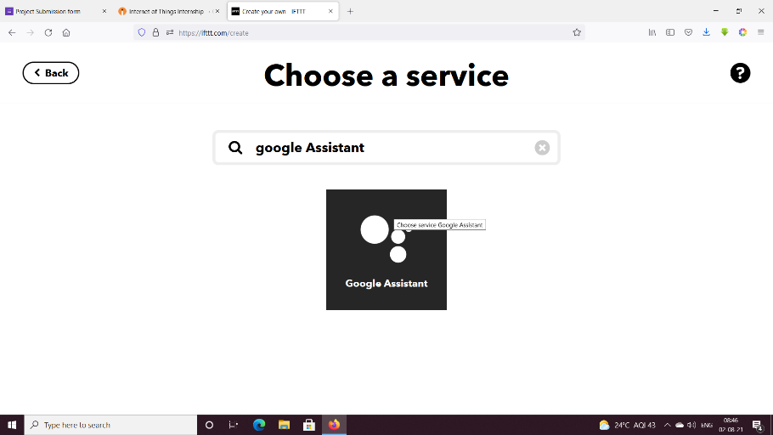

* Select “Say a phrase with a text ingredient”.

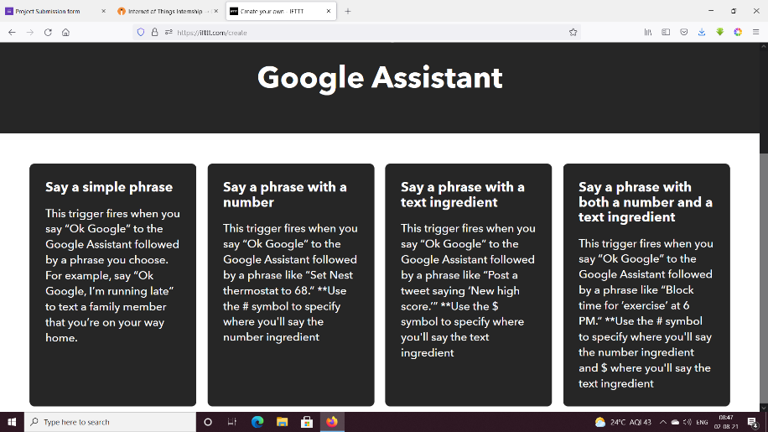

* Click on Create trigger

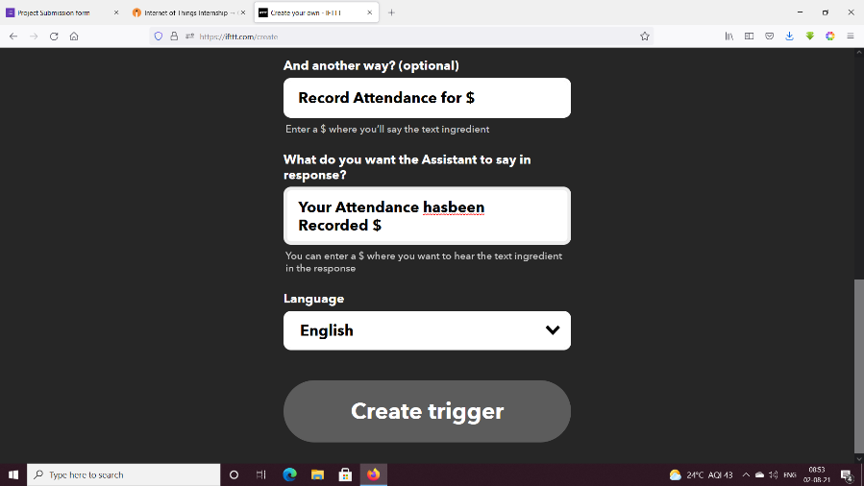

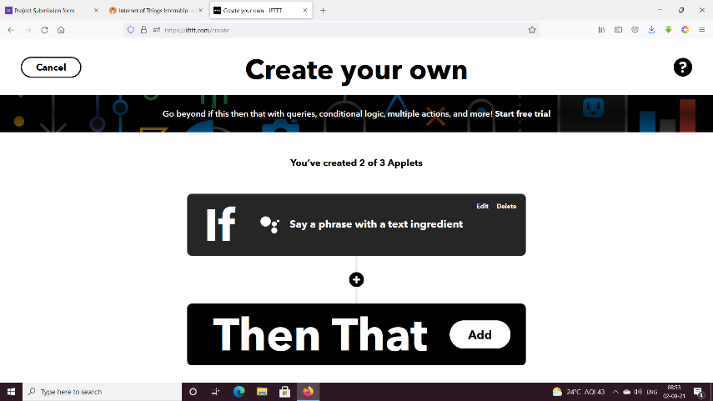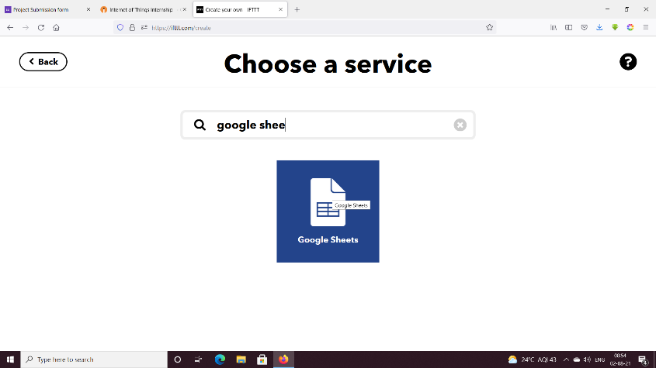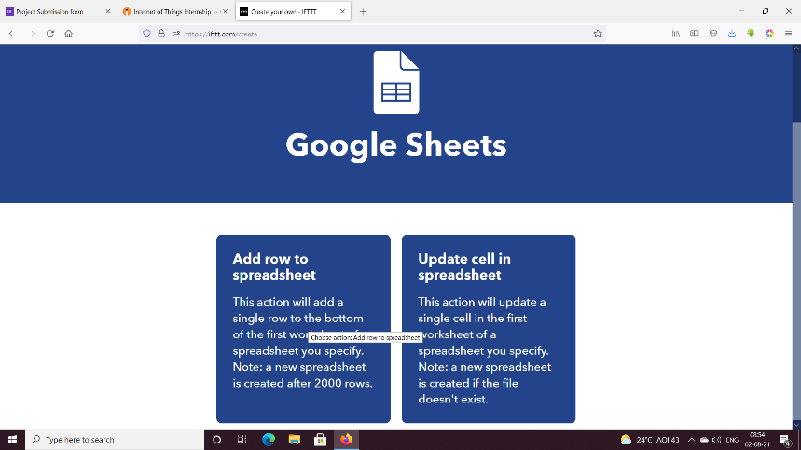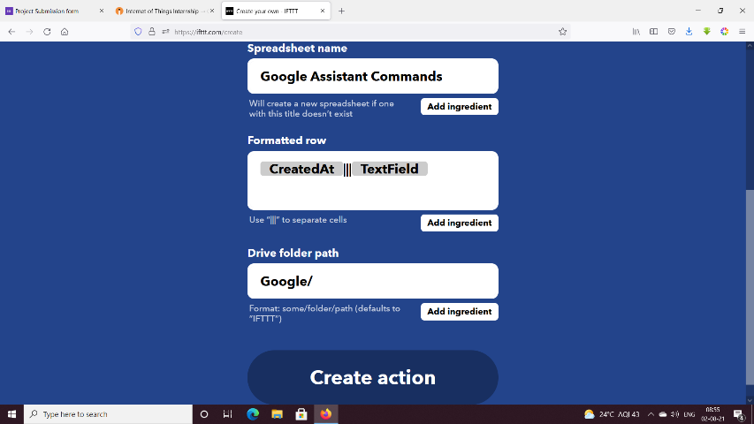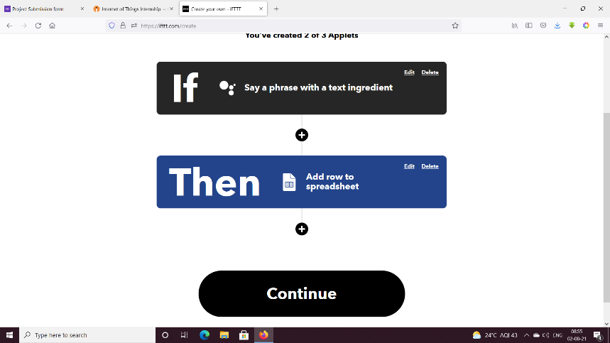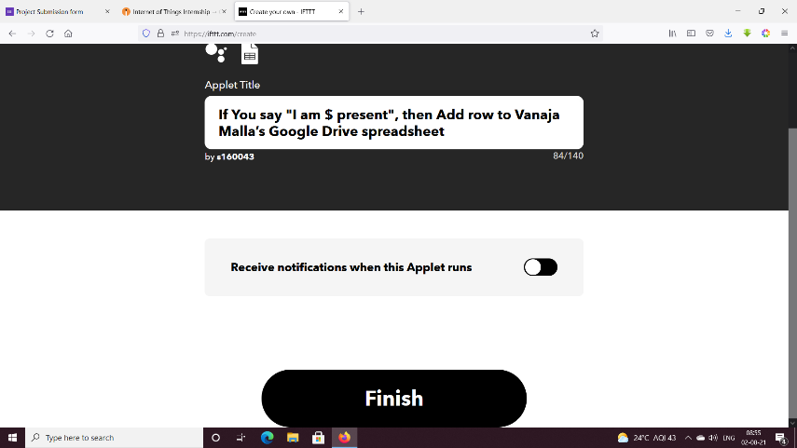

Step 3 : Final Check

